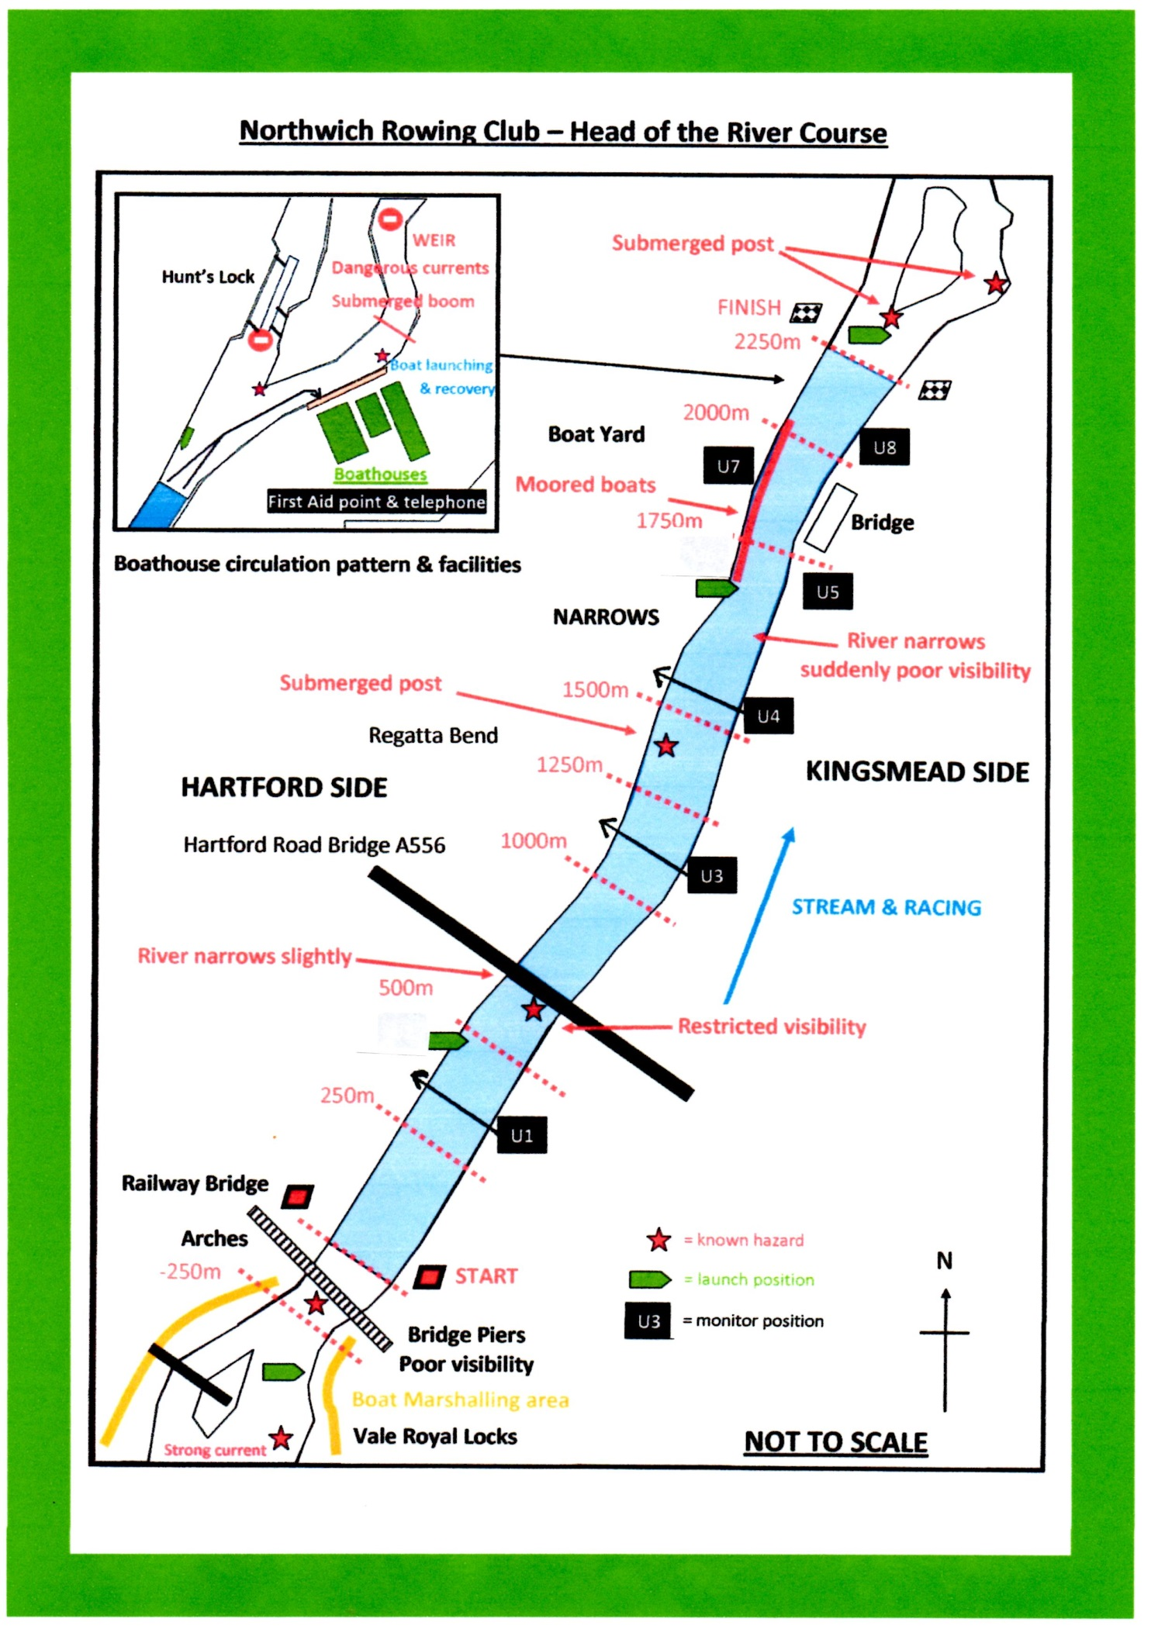
Access Point 5
Access Point 4
Access Point 1
Access Point 2
Access Point 3
Access point 1 - SJ 656 728 Northwich Rowing Club, The Crescent, Northwich CW9 8AE
Access point 2 - SJ 653 723 The Fisherman’s Car Park, off Bickley Close (Kingsmead) Northwich, CW9 8TJ
Access point 3 - SJ 646 713 The Fisherman’s Car Park at the West Side (Hartford Side) of Hartford Blue Bridge on the A556 Westbound
Access point 4 - SJ 647 712 The East Side (Davenham Side) of Hartford Blue Bridge on the A556 Westbound
Access Point 5 - SJ 641 706 The Fisherman’s Car Park at the Railway Viaduct accessed along Vale Royal Drive, the first road
immediately left after Hartford Blue Bridge on the A556 Westbound

